# Connecting to TFS Server (MS Visual Studion 2017)

Contents

Connecting to TFS Server (MS Visual Studion 2017) 1

Before you start 1

Connecting to TFS Server 2

Launching the Solution 7

## Before you start

Make sure you have selected .NET desktop development from the Workloads section as part of the initial install, if you don’t you will experience lots of problems!

If you did not select .NET desktop development from the Workloads section, go back to the Visual Installer

Select .NET desktop development and continue with the installation.

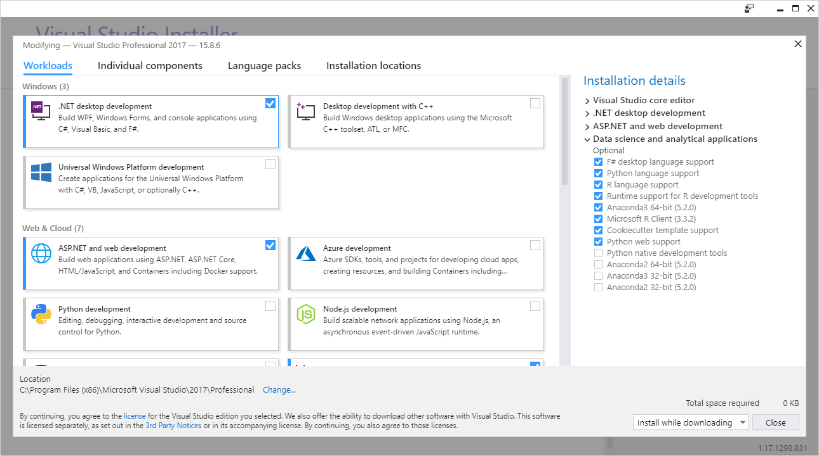

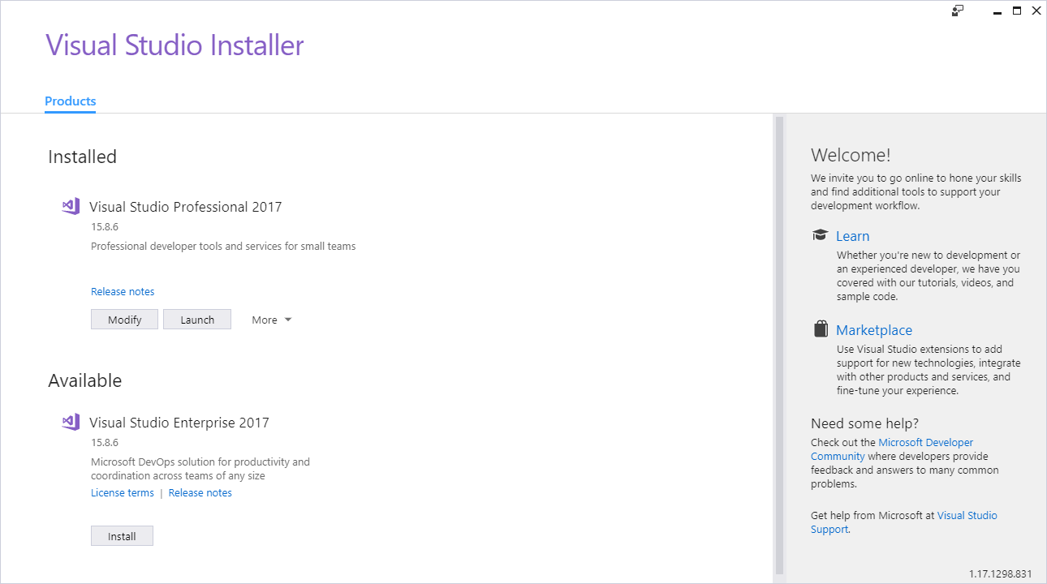

Select Modify

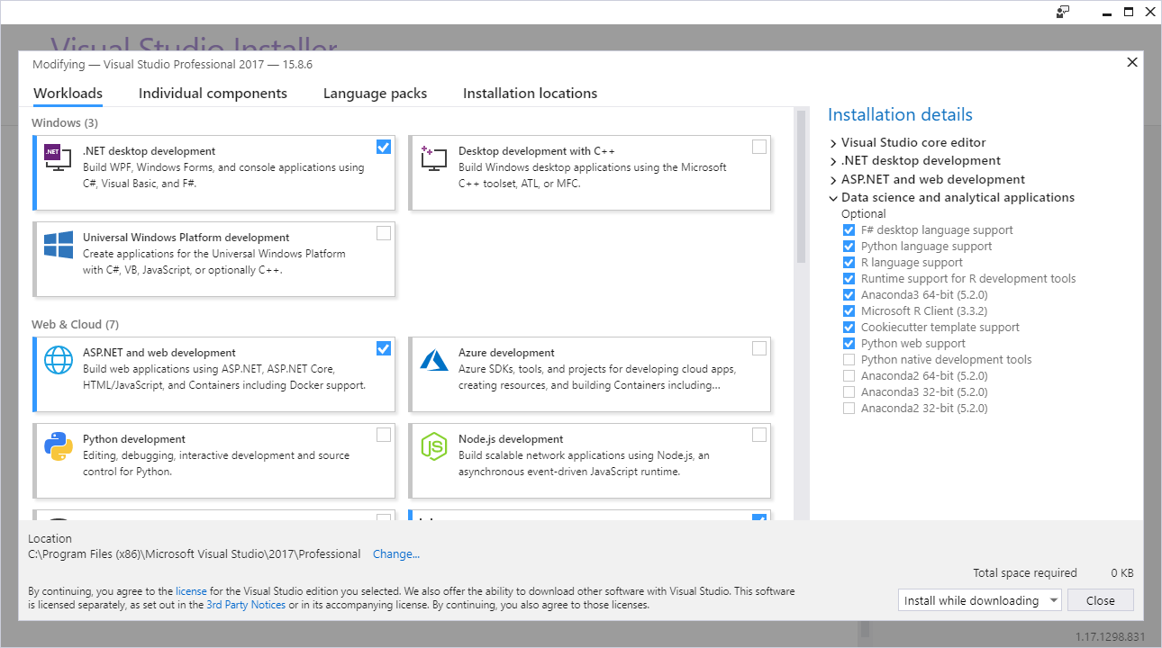

## Connecting to TFS Server

From Team Explorer Window, click on the green connector icon at the top of the screen

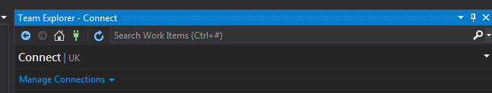

Click on Manage Connections-> Connect to Project

(Note: TFS shown in the screenshot below will not be visible until you have successfully connected)

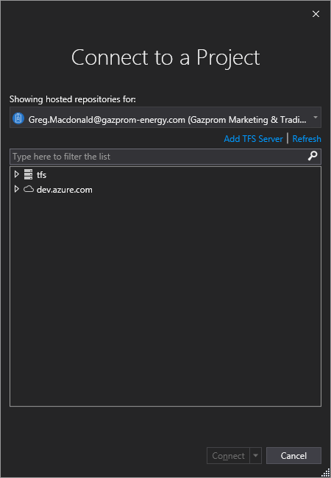

Click on Add TFS Server

Type

<http://tfs:80/tfs>

(Some instructions omit the :80, but I found that it was required because the port was defauting in to 8080)

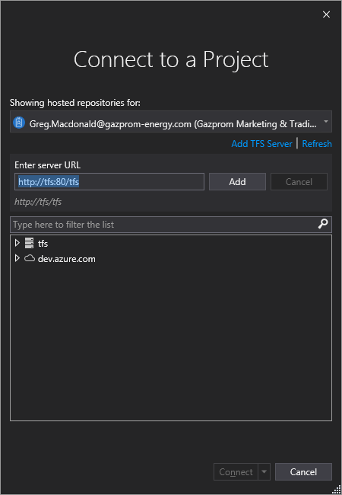

Click on Add

Now you can locate the 'UK' folder within .\GazpromEnergy\UK\ and click Connect

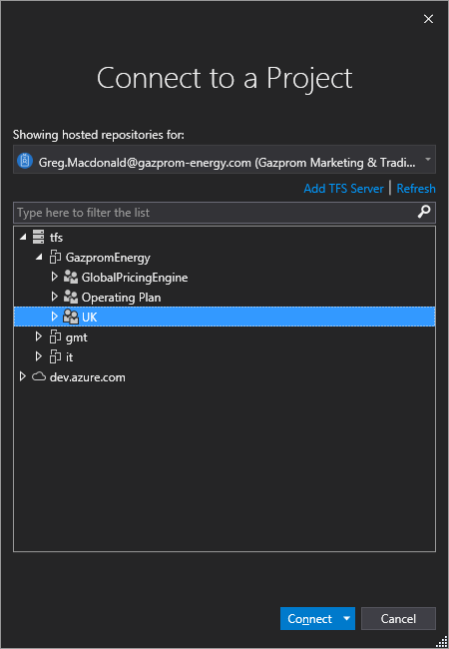

1. Append 'Portal' to the two paths in the following dialogue box:

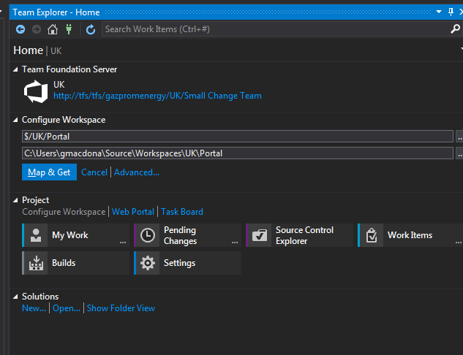

Click Map & Get  
You should get a pop up box as follows:

1. 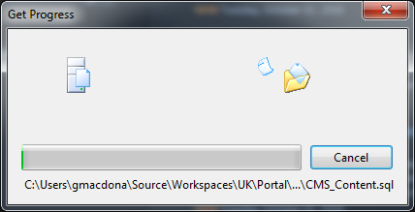

When complete the following will be shown near the top of the screen:

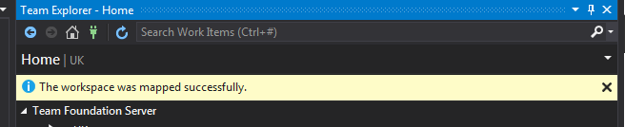

## Launching the Solution

Navigate to C:\Users\<YourUsername>\source\Workspaces\UK\Portal\Main\Source and double-click on Portal.sln.

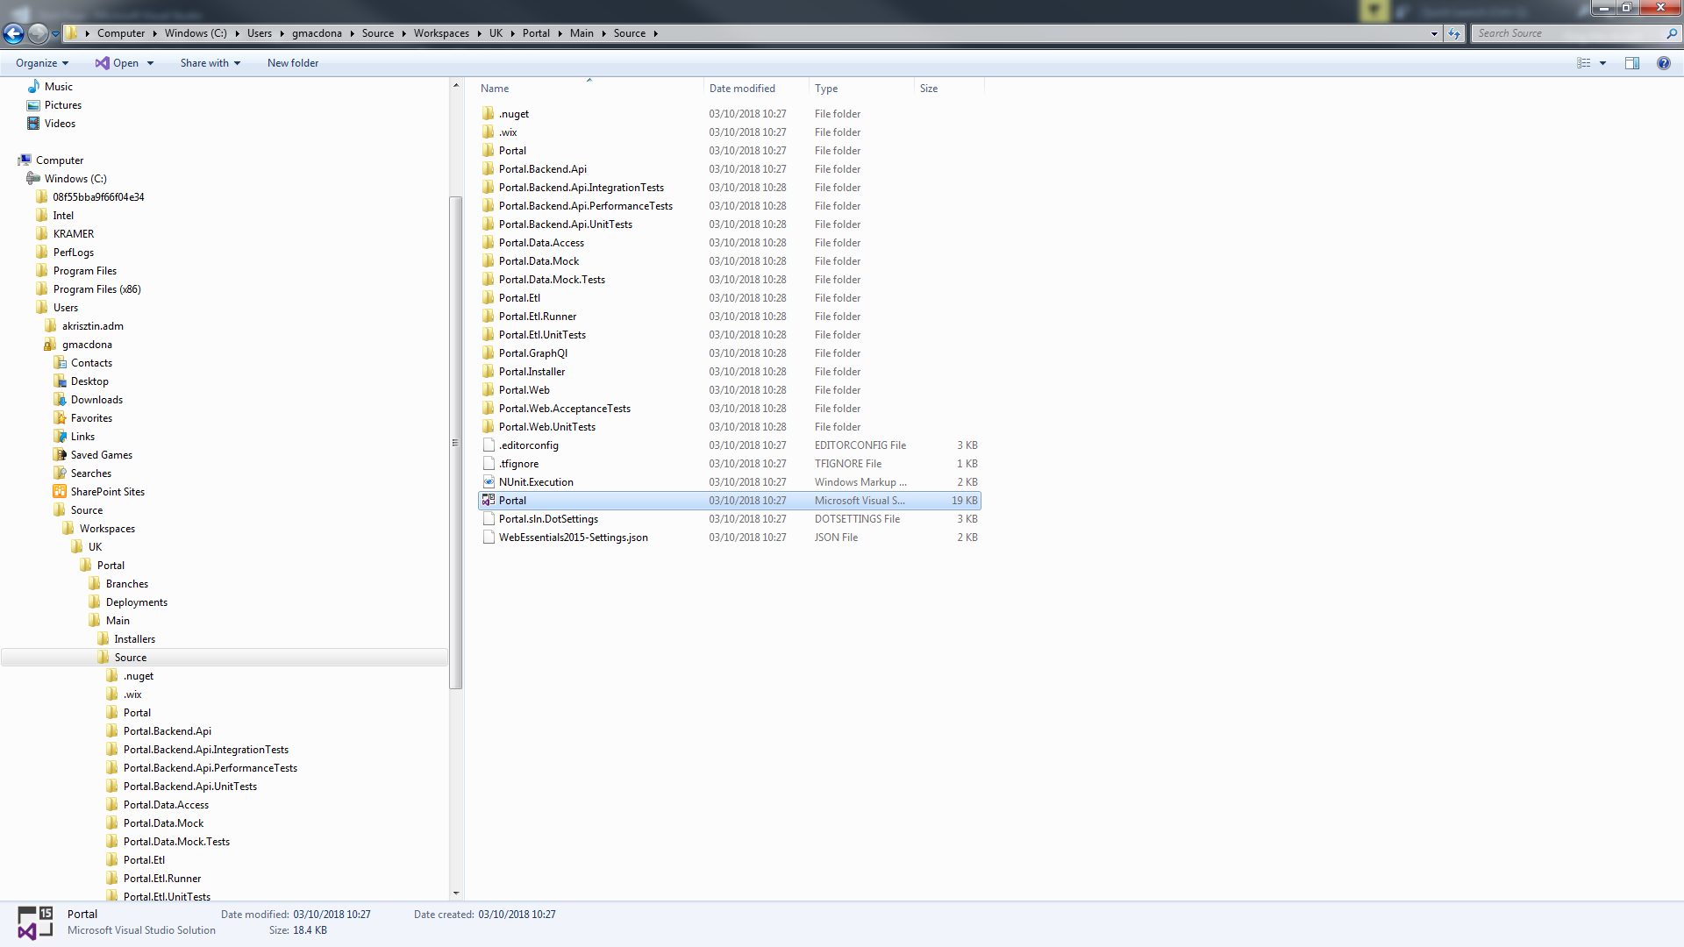

You may get a screen like this. If so, speak to Tolli to see what needs to be done

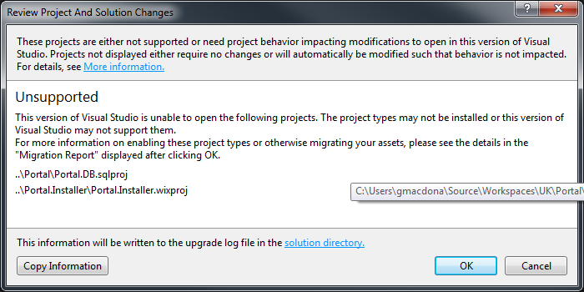

Click on OK

You may get a screen like this, if so just click on Install

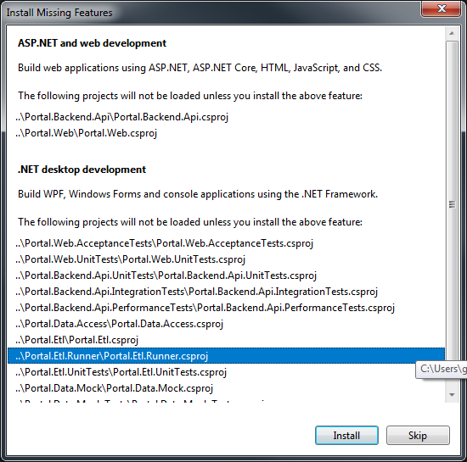

## Building the Portal Solution

Navigate to Tools->NuGet Package Manager->Package Manager Settings

Select NuGet Package Manager -> Package Sources

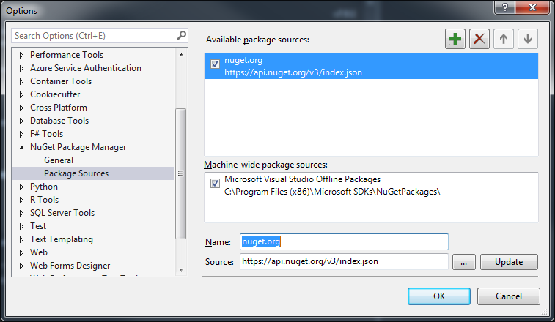

Change Name to Proget GE

Change Source to <http://proget1:81/nuget/GazpromEnergy>

Now select Build->Clean and Build->Rebuild to check that all projects build with no errors.

### NOTE:

.NET Framework 4.6.1

REG_DWORD = (394271)